ST MARY MAGDALENE CHURCH

WARDINGTON

WELCOME TO THE PARISH OF WARDINGTON

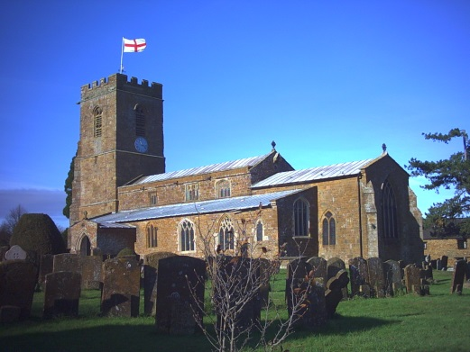

WELCOME MESSAGE FROM THE VICAR,
THE REVD HILARY CAMPBELL
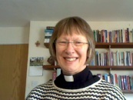
We believe that the church should be at the heart of life here in this community. You will always be welcome at any of our services or events, or just to step inside for a time of reflection. We are people who want to explore the way of Christian faith. We offer the church building as a place for the community to gather at times of need, commitment and celebration.
Hilary Campbell, Tel: 01295 750385 vicar@campbells.me.uk
COME AND JOIN US....

First Sunday 10.00am Family Service
Lay led service for all ages with refreshments afterwards
Second Sunday No regular service but see Church noticeboards for other benefice services
Third Sunday 10.00am Family Communion
A family friendly Holy Communion service with refreshments afterwards
Fourth Sunday No regular service but see Church noticeboards for other benefice services
Fifth Sunday No regular service but see Church noticeboards for other benefice services
There are weekday services for those who may find Sunday services less convenient. Service times are routinely posted on the Church noticeboards and the village website: www.wardington.net/st-mary-magdalene/.

HOW CAN YOU GET INVOLVED?
It is easy to think that all that happens in the Church are services on Sunday and other events such as Christenings, Weddings and Funerals. While, in a sense that is true, none of these events can take place without the Church and the churchyard being well kept and welcoming.
At St Mary Magdalene Church we work on the principle of organising many volunteers each helping in small ways to make a difference to the overall attractive appearance of the Church and the sense of community in our services.
Prior to Sunday services we are very fortunate to have a team of bellringers to welcome the congregation, a flower rota team who always make the church look fresh and inviting, and sidesmen who are responsible for setting up the church prior to services.
After the service we usually have refreshments where a member of the congregation provides tea, coffee and cake. This provides an ideal opportunity for the congregation to meet the Vicar and each other in relaxed surroundings.
The churchyard is mown by a team of volunteers each of whom have a specific area of the churchyard to look after.
Church administration is the responsibility of the Parochial Church Council who meet five times a year to plan services, pastoral activities, church maintenance, financial matters and other church activities.
About thirty people support all these activities which are so important for the wellbeing and the future of the church. Whether you are a potential bell ringer, flower arranger, cake maker, mower, event planner or would be interested in some of the administrative aspects of making the Church special, and have even a small amount of time available, contact one of the Churchwardens who would be delighted to discuss how you could join the team.
“FRIENDS OF WARDINGTON CHURCH”

The "Friends" organise social events to raise money for improvements to the fabric of the church. Recently this has included a new digital organ, upgrading the heating, a security system for the roof, new bell ropes and the complete renovation of the Lady Chapel.

Events organised include "Call my Wine Bluff", the midsummer "Safari Supper" and carol singing on the green in Upper Wardington. These events are very popular and have become part of the social fabric of Wardington. They are also an excellent opportunity to meet fellow villagers, old and new.

The committee are always keen to welcome new members and to accept any help on offer. Please contact the chairman, Steve Mackenzie-Lawrie, at steve.mlawrie@btinternet.com

HOW TO CONTRIBUTE TO CHURCH FUNDS

Contrary to the popular belief of many the Church of England does not have a central resource that funds the cost of running individual parish churches. St Mary Magdalene Church is responsible for raising its own funds to ensure that it is maintained in a good state of repair and available not only for routine services but also Christenings, Weddings, Funerals and other special services.

The annual operating cost is around £16,000 - or looked at more closely some £300 per week – with the principal costs being the clergy, utilities, insurance and repairs. Over half this cost is funded through regular voluntary contributions, both large and small, from less than 5% of the households in the parish. If you feel you could assist, this is how:

- Send a donation(s) to the PCC Treasurer
- Become a regular supporter by joining the Parish Giving Scheme with a Direct Debit mandate. All the sums you donate, including the related Gift Aid tax refund, go directly to the Church
- Help us reclaim the tax on any other donation by signing a Gift Aid Declaration

BRIEF HISTORY OF THE CHURCH

The earliest parts of the Church date from the 12th century. It is an interesting example of the work of country masons using local stone, quarried from the hill to the east of the village, and it provides good examples of architecture covering the years from the 12th to 15th centuries. The Church consists of a chancel, nave, south and north aisles, vestry, lady chapel and an embattled tower.

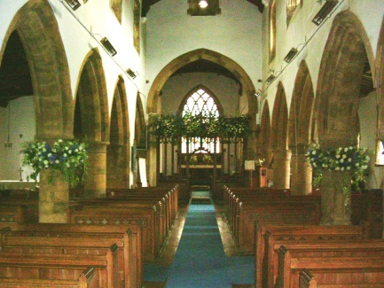

The chancel is particularly interesting since it provides the evidence that this Church existed by the year 1150. In the south wall there is a deep, splayed, round-headed, 12th century window (formerly an outside window) which matches that of the north wall of the chancel. The chancel is 14th century which is when it was rebuilt on the site of, in all probability, an earlier chapel.

The nave is 13th century and of significance are the five low early English arches on each side on circular columns, none of which are identical. The clerestory and the tower date from the 15th century, the latter being in three stages with a crenelated parapet and diagonal buttresses.

The tower houses a peal of six bells, three of which date back to the 17th century and were cast in a foundry in nearby Chacombe. The bells were re-hung in 1998 to mark the millennium. The present tower clock, with east and west faces, dates from 1900. The font, adjacent to the south door, originates from 1666.

The Church is Grade I listed along with nine Grade II listed chest tombs in the Churchyard.
SHIRES’ EDGE BENEFICE

The parish of Wardington is part of the group of churches known as Shires' Edge Benefice, which consists of St James the Great, Claydon; St Mary the Virgin, Cropredy; All Saints', Great Bourton; All Saints', Mollington and St Mary Magdalene, Wardington. A monthly leaflet, available in each church, provides information on services and events in the Benefice, as well as being published on village websites. Within the Benefice there is a church school, Cropredy CE Primary School: www.cropredyprimaryschool.org.uk/.

BAPTISMS, WEDDINGS & FUNERALS

The Church is here to be alongside people in all the joys and sorrows of life events: times of new beginnings, commitment to one another and times of grief and remembering. To arrange a christening or baptism, to ask about confirmation, interested in getting married in church, or to arrange a funeral service, please contact the Vicar.

WHO’S WHO

Vicar Revd Hilary Campbell 750385 vicar@campbells.me.uk
Assistant Priest Revd Lynda Alcock 750744 lynalcock@outlook.com
Authorised Assistant Sue Upton 758398 redhouse2006@btinternet.com
Churchwarden Nigel Bankes 750500 nigelbankes23@gmail.com
Churchwarden Clive Hunt 758087 clippa.comms@btinternet.com
PCC Treasurer Clive Hunt 758087 clippa.comms@btinternet.com
Tower Captain Nikki Stell 758301 nikki@stellfamily.plus.com
Friends of Church Steve Mackenzie-Lawrie 758369 steve.mlawrie@btinternet.com
Church Flowers Ginny Steven 750765 ginny@asteven.com

CHURCH WEBSITE & POST CODE

Post Code: OX17 1RS
E-mail: wardington.church@btinternet.com
Website: www.wardington.net/st-mary-magdalene/

